RIHAM AHAMED ABDUL RAHEEM

HND COMPUTING IDM

Trinity school database MANagement system

Contents

Acknowledgment 1

Introduction 2

Modelling the database 2

Entity Relationship Diagram 2

Use case diagram 3

Data flow diagram 4

Specification for the intended users of system. 5

Identified requirements for the system 6

Operating system requirements 6

Minimum System requirements 6

Identified requirements for the DataBAse system 6

Data normalization 8

1st Normal Form (1NF): 8

2nd Normal Form (2NF): 8

3rd Normal Form (3NF): 8

Class Table: 9

Supplier Table: 9

Instrument Table: 10

Student Table: 10

Teacher Table: 11

System Design 12

Effectives of the design 15

user requirements 15

System requirements 16

References 17

**List of figure**

Figure 1: Trinity Music School ER Diagram 2

Figure 2: Trinity Music School Use case diagram 3

Figure 3: Level 0 Data flow diagram 4

Figure 4: Level 1 Data flow diagram 4

Figure 5: Login form Design 12

Figure 6: Student form Design 13

Figure 7: Main Menu form design 13

Figure 8: Message box form design 14

Figure 9: User's add or delete form design 14

# Acknowledgment

We are really grateful because we managed to complete our Database assignment within the time given by our lecturer **Mr. Sasikumar** this assignment cannot be completed without the effort and co-operation from our lecturer. So, I sincerely thank our lecturer of Database for the guidance and encouragement in finishing this assignment and also for teaching us in the course. Last but not least, we would like to express our gratitude to our friends and respondents for the support and willingness to spend some times with us to fill in the questionnaires.

# Introduction

The Colombo-based Trinity Music School is currently erratic and outdated, requiring XYZ software solutions to create a corresponding database system for the school to transform their entire school with data processing methods to meet the school's demands for development and flexibility. Based registration management system.

This report seeks to justify, explain, and clarify the specifics and semantics of the relevant database created at their request.

# Modelling the database

## Entity Relationship Diagram

The organizational Entity Relationship diagram (ERD) was used as a modeling technique to model the database. During the modeling phase, 5 different Entity and their characteristics were identified according to the visual and stated needs of the school. On closer inspection, it was found that these companies have relationships between them. After a thorough study, the relationships were determined and properly mapped.

Figure 1: Trinity Music School ER Diagram

## Use case diagram

Figure 2: Trinity Music School Use case diagram

Use case diagram (UCD) was used as a modeling technique to model the database. This technique was used to identify potential users of the computer, classify them, and identify how and where data flows within the school. At this modeling stage, users were categorized. The actors shown on the map do every one of those actions. (tutorialspoint, 2021)

During this modeling phase, 3 users (admin, consumer, sponsor) were identified in addition to the 3 mentioned in the scene (student, teacher, supplier).

Supported user is not proven here to prevent any interaction with that type of user system, but only on one side. It was decided that this type is user-friendly.

Administrators and consumers will make direct contact with the computer, while teachers and students will be the users that affect the actions of the aforementioned administrators and consumers.

However, it is good to note that the actual system may or may not follow the actual announced data flows or support for the announced cast.

## Data flow diagram

Figure 3: Level 0 Data flow diagram

USER

Student

Teacher

Class

Instrument

Supplier

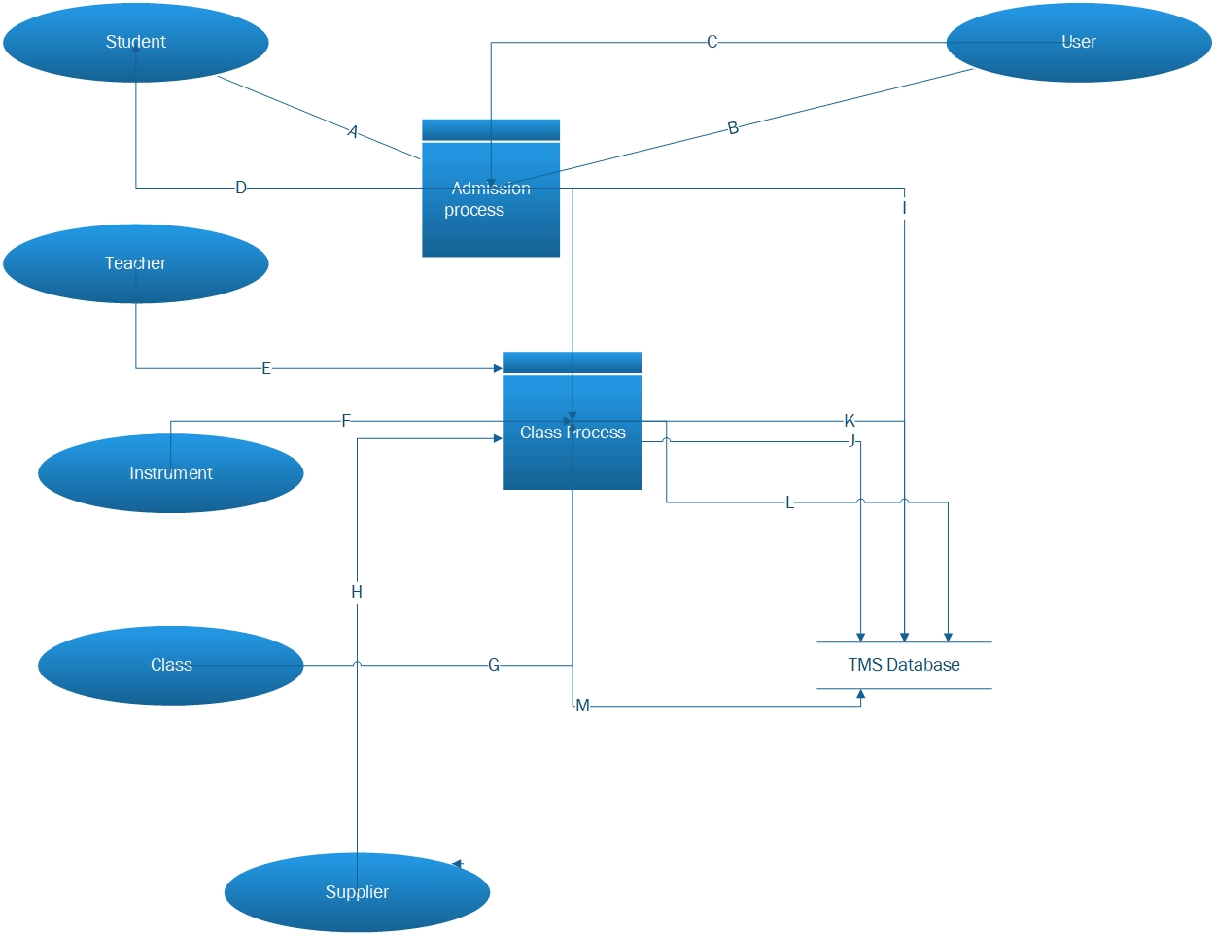

Figure 4: Level 1 Data flow diagram

1. Show the correct details.
2. View the student details.
3. Student details if correct register the student.
4. Give the registration report.
5. Teach the class
6. Rent the instrument details.
7. Register the new classes.
8. Buy the new instrument.
9. Store the Student registration details.
10. Store the rental instrument details.
11. Store the Teacher details.
12. Store the classes details.
13. Store the supplier detail

# Specification for the intended users of system.

Generally, all users of this system must meet the following criteria:

* + - 1. Have a history of ethically exposing other well-known application software.

1. Must be within their operational limits.
2. Have a primary sense in reporting any and all strange behaviors to the school’s IT staff.
3. Obey all school procedures.

Users are categorized into 3 groups, depending on the role they have to play in extracting the best out of the system. Namely, Admins, Consumers and supporters.

Admin users have read / write permissions, can change the passwords of consumers and other administrators, create consumer accounts, backup and restore the database, and completely erase all data in the database. Admin users are advised not to run the system too often. Administrators may have consumer accounts to participate in reading / writing activities.

Consumer users have read / write permissions for all formats throughout the system. These users will actively and frequently operate the system by interacting with students, suppliers and other external visitors.

Support users will not interact with the system. They are there for the purpose of ensuring that the system works properly and to report management level or IT staff in case of sufficient error.

It is highly recommended that these 3 types of users be offered to those who operate within the company. In addition to IT staff and front office operators, one of these user roles can only be assigned to teachers

# Identified requirements for the system

Upon processing the scenario, before the modelling stages of the data base system several requirements were identified.

The many database developing software are in the world but I use the Software **Microsoft SQL Server Management Studio.** The software is user-friendly software. MS SQL requirements are:

Operating system requirements.

* Windows 10 (64-bit) version 1607 (10.0.14393) or later
* Windows 8.1 (64-bit)
* Windows Server 2019 (64-bit)
* Windows Server 2016 (64-bit)
* Windows Server 2012 R2 (64-bit)
* Windows Server 2012 (64-bit)
* Windows Server 2008 R2 (64-bit)

Minimum System requirements.

* 1.8 GHz or faster x86 (Intel, AMD) processor. Dual-core or better recommended
* 2 GB of RAM; 4 GB of RAM recommended (2.5 GB minimum if running on a virtual machine)
* Hard disk space: Minimum of 2 GB up to 10 GB of available space (Microsoft, 2021)

# Identified requirements for the DataBAse system

Upon processing the scenario, before the modelling stages of the data base system several requirements were identified.

Trinity’s **primary requirement** is to be provided with a database to keep records of:

1. Classes.
2. Teachers that teach on a class.
3. Students that participate in a class.
4. Instruments rented for a particular class.

Trinity’s **secondary requirements** that were identified:

1. Class records must contain ClassID, Start_Date, End_Date, Fees, StudentID, TeacherID, InstrumentID attributes.
2. Instrument records must contain instrumentID, Name, Quantity, Rental_Price, ClassID, SupplierID attributes.
3. Student records must contain StudentID, Name, Type, DOB, Register_Date, Contact_Number, ClassID attributes.

Trinity’s **tertiary requirements** that were identified:

1. Activate each type of musical instrument offered by only one company.
2. Execute the rental formula as “NumberOfInstruments * Period”.
3. There can be many students if one class is implemented.
4. A student can have multiple classes.
5. Enable student classification of "full_time" and "part-time" categories.
6. A teacher can have multiple classes.
7. There can be many teachers if one class is implemented.

All primary, secondary and tertiary requirements have been attempted to be factored into the system by creating a model that respects the nature of these requirements, and a database that can obey the nature of the model. (Springs, 2021)

# Data normalization

Data normalization is the process of organizing data into a database, which is the main 3 insertion, update and deletion conflicts by distorting tables to get rid of data review and other complex conflicts. The process consists of several steps, each of which provides a step-by-step schedule towards a better structure.

## 1st Normal Form (1NF):

1. Must contain only columns of atomic value.
2. All values ​​in a column must be the same data type.
3. All columns in the table must have unique names.
4. The order of data storage is not a bar.

## 2nd Normal Form (2NF):

1. Must be at 1NF.
2. The composite must not have any properties depending on a part of the primary key.

## 3rd Normal Form (3NF):

1. Must be at 2NF.
2. All the properties in the table should depend only on the main properties of the primary key.

There are 2 main benefits to having a default database:

* Increased stability: Information is stored in one place and in one place only, which reduces the possibility of random data.
* Object Easy object-to-data mapping: Generally, most standardized data programs are conceptually close to object-oriented programs because objective objectives that promote more synchronous and loose connections between classes yield similar solutions.

You will want to have default data stores and databases.

The main disadvantage of normalization is slow reporting performance. You want to have an irregular plan for efficient reporting, especially in data marts.

All tables will be normalized to the third normal format. Below each table in the database is visualized, normalized and justified. (Guru99, 2021)

### Class Table:

|  |  |  |  |  |  |  |
| --- | --- | --- | --- | --- | --- | --- |
| Class | | | | | | |
| classID (Integer) | StudentID (Integer) | InstrumentID(Integer) | TeacherID (Integer) | Start_Date (datetime) | End_Date (datetime) | Fees (money) |
| 0001 | 0001 | 0001 | 0005 | 2021.04.04 | 2021.10.04 | 5000 |

Primary key: classID

This table is in the 3rd normal because:

1NF – All values are atomic, have the same data type and columns have unique names.

2NF – Is already in 1NF and all attributes depend on the primary key classID.

3NF – Is already in 2NF and all attributes depend only on classID.

### Supplier Table:

|  |  |  |  |  |
| --- | --- | --- | --- | --- |
| Supplier | | | | |
| SupplierID (Integer) | InstrumentID (Integer) | Name (Varchar (100)) | Address (Varchar (200)) | Contact_Number (Integer) |
| 0001 | 0001 | Mark | Colombo | 0777414741 |

Primary key: SupplierID

This table is in the 3rd normal because:

1NF – All values are atomic, have the same data type and columns have unique names.

2NF – Is already in 1NF and all attributes depend on the primary key SupplierID.

3NF – Is already in 2NF and all attributes depend only on SupplierID.

### Instrument Table:

|  |  |  |  |  |  |
| --- | --- | --- | --- | --- | --- |
| Instrument | | | | | |
| InstrumentID (Integer) | SupplierID (Integer) | ClassID  (Integer) | Name (Varchar (100)) | Quantity (Integer) | Rental (money) |
| 0001 | 0001 | 0001 | Piano | 5 | 15000 |

Primary Key: InstrumentID

This table is in the 3rd normal because:

1NF – All values are atomic, have the same data type and columns have unique names.

2NF – Is already in 1NF and all attributes depend on the primary key InstrumentID.

3NF – Is already in 2NF and all attributes depend only on InstrumentID.

SupplierID is a foreign key referencing the column SupplierID from the supplier table, but this column depends entirely on the InstrumentID in this table.

### Student Table:

|  |  |  |  |  |  |  |
| --- | --- | --- | --- | --- | --- | --- |
| Student | | | | | | |
| StudentID (Integer) | Name (Varchar (100)) | Type (Varchar (50)) | DOB (Date) | Register_ Date (Date) | ClassID (integer) | Contact_ Number (Integer) |
| 0001 | Ajith | Full Time | 1999.08.05 | 2021.04.04 | 0001 | 0777535753 |

Primary key: StudentID

1NF – All values are atomic, have the same data type and columns have unique names.

2NF – Is already in 1NF and all attributes depend on the primary key StudentID.

3NF – Is already in 2NF and all attributes depend only on StudentID.

### Teacher Table:

|  |  |  |  |
| --- | --- | --- | --- |
| Teacher | | | |
| TeacheID (Integer) | ClassID (Integer) | Name (Varchar (100)) | Contact_Number (Integer) |
| 0001 | 0005 | Alison | 0774565159 |

Primary key: TeacheID

1NF – All values are atomic, have the same data type and columns have unique names.

2NF – Is already in 1NF and all attributes depend on the primary key TeacherID.

3NF – Is already in 2NF and all attributes depend only on TeacherID.

# System Design

What is System design?

* System design is the process of designing components of a system, such as the structure, modules and components, the different interfaces of those components and the data that passes through that system.

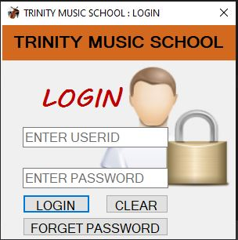The designs are designed to be as self-explanatory and as minimal as possible while maintaining user-friendliness. Here are some screenshots of the system design:

Figure 5: Login form Design

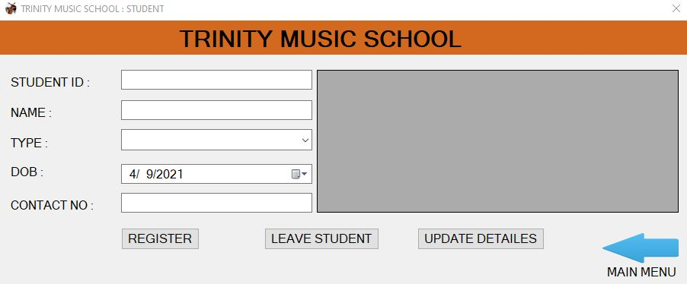The student form design related other forms Class, Teacher, Instrument and supplier

Figure 6: Student form Design



Figure 7: Main Menu form design

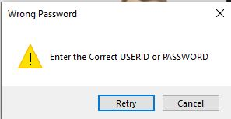

Figure 8: Message box form design

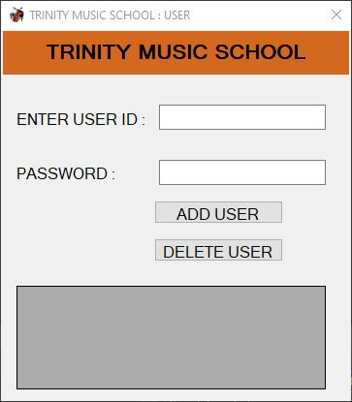

Figure 9: User's add or delete form design

# Effectives of the design

## user requirements

This design is designed so that anyone with previous experience with some kind of application software like Microsoft Office suite can easily navigate through the computer and do any task they want to do.

Whenever the system encounters an error, the user will be notified using a message box, which the user should report supporting or knowledgeable IT staff who can provide them with the support they need, or refer to the technical documentation for assistance.

With this relational database system, all the hassles experienced by Trinity will be effectively overcome, but for this, users need to be trained to use the system.

It is highly recommended that users specify documents within the first few days of system exposure.

A satisfactory attempt was made to satisfy all user requirements demonstrated in the scenario.

## System requirements

All primary requirements have been met as there are respective tables for changing Trinity records. A table has been created to meet each of the primary requirements.

Data verification is achieved by implementing data types by embedding a plan for each table in the database. Only data of a limited data type can be stored in each table.

Additional barriers such as NOT NULL, UNIQUE, PRIMARY KEY or FOREIGN KEY have been implemented to ensure that the system works optimally and that the stored data is consistent.

In order to meet all the secondary requirements, the respective companies in the modeling stages were assigned with the properties declared in the Scenario, which were then converted into columns of a specific table in the development stages.

All enforcements described as tertiary requirements have been achieved through FOREIGN KEY constraints, composite primary keys and at times separate tables in order to ensure the various relationships between each entity of the modelling stage.

Since all 3 types of system requirements are met, it can be said that the system is designed to meet all the requirements.

It is fair to say that the system has the potential to fulfill all the requirements of the Trinity Music School in an ideal and efficient manner, as the design of the system meets both the user and the system requirements.

# References

Guru99, 2021. *What is Normalization? 1NF, 2NF, 3NF, BCNF Database Example.* [Online]   
Available at: https://www.guru99.com/database-normalization.html  
[Accessed 04 04 2021].

Microsoft, 2021. *Download SQL Server Management Studio (SSMS).* [Online]   
Available at: https://docs.microsoft.com/en-us/sql/ssms/download-sql-server-management-studio-ssms?view=sql-server-ver15  
[Accessed 04 04 2021].

Springs, S., 2021. *subjectguides.* [Online]   
Available at: https://subjectguides.esc.edu/researchskillstutorial/primary#:~:text=Data%20from%20an%20experiment%20is,one%20step%20removed%20from%20that.&text=Tertiary%20sources%20summarize%20or%20synthesize,reference%20books%20are%20tertiary%20sources.  
[Accessed 04 04 2021].

tutorialspoint, 2021. *TUTORILASPOINT_SIMPLYEASYLEARNING.* [Online]   
Available at: https://www.tutorialspoint.com/uml/uml_use_case_diagram.htm  
[Accessed 04 04 2021].